Yuwen Sang

Jan. 26, 2021

COMP 3421: A2

1. ***E/R Schema***

* Customers (**customerID**, cname, age, gender, SSN, dlNum, **coverageID, stateName**)
* Cars (**VINcode,** brand, color, ctype, **customerID**)
* ~~Plans (~~**~~planName~~**~~)~~
* City (**cityName,** climate, pDensity)
* Driving Records (**recordID,** DRdate, DRtype)
* Coverage (**coverageID,** cAmount**,** planName**,** price)
* Premium (**premiumID**, paymentPeriod, cAmount**, recordID, customerID**)

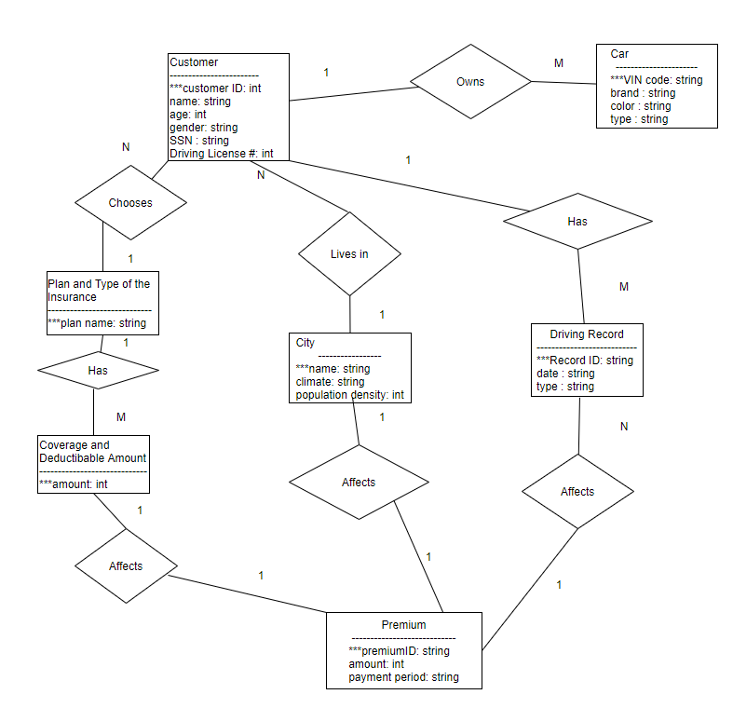

1. ***SQL Create Tables***

*Code (Commands):*

show databases;

drop database if exists carInsurance;

create database carInsurance;

use carInsurance;

# create 7 tables

#1. Customers

drop table if exists Customers;

create table Customers(

customerID int NOT NULL,

cname varchar(30),

age int,

gender varchar(10),

ssn int,

dlNum int,

planName varchar(20) NOT NULL,

cityName varchar(20) NOT NULL,

primary key (customerID));

describe Customers;

#2. Cars

drop table if exists Cars;

create table Cars(

VINcode int NOT NULL,

brand varchar(15),

color varchar(15),

ctype varchar(10),

customerID int NOT NULL,

primary key (VINcode));

describe Cars;

#3. Plans

drop table if exists Plans;

create table Plans(

planName varchar(20) NOT NULL,

primary key (planName));

describe Plans;

#4. Cities

drop table if exists Cities;

create table Cities(

cityName varchar(20) NOT NULL,

climate varchar(15) NOT NULL,

pDensity int NOT NULL,

primary key (cityName));

describe Cities;

#5. DrivingRecords

drop table if exists DrivingRecords;

create table DrivingRecords(

recordID varchar(20) NOT NULL,

DRdate varchar(15),

DRtype varchar(20) NOT NULL,

customerID int NOT NULL,

premiumID int NOT NULL,

primary key (recordID));

describe DrivingRecords;

#6. Coverage

drop table if exists Coverage;

create table Coverage(

cAmount int NOT NULL,

planName varchar(20) NOT NULL,

primary key (cAmount));

describe Coverage;

#7. Premium

drop table if exists Premium;

create table Premium(

premiumID varchar(20) NOT NULL,

pAmount int NOT NULL,

paymentPeriod varchar(15),

cAmount int NOT NULL,

cityName varchar(20) NOT NULL,

primary key (premiumID));

describe Premium;

*Output of Running above Commands:*

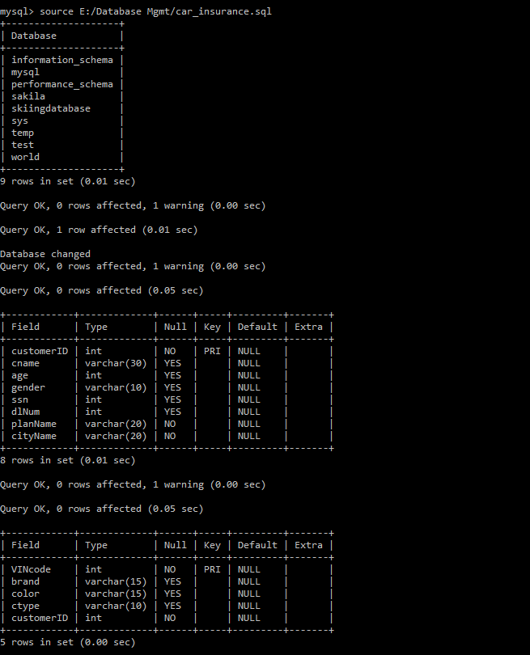

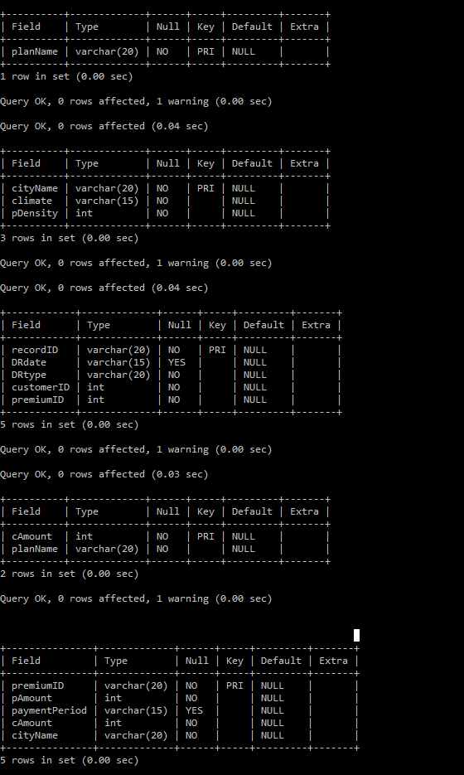

1. ***Inserting 3 tuples into Customers Table and Using “select” Command to Show***

*Commands:*

insert into Customers values (1,'Alice', 25, 'female', 12345678, 000000000, 'Gold', 'Denver');

insert into Customers values (2,'Bob', 25, 'male', 12345677, 1112223334, 'Silver', 'New York');

insert into Customers values (3,'Susan', 25, 'female', 12345676, 100000001, 'Plantium', 'Chicago');

select * from Customers;

*Output:*

